# Data Description – Simulated data

The SimulatedDataset_normal.xlsx and SimulatedDataset_fouled.xlsx contains data from a simulation of a heat exchanger in a normal situation and in a fouled situation.

It consists of data from a simulation of a heat exchanger system created with Simulink.

Naming of sensor data:

- T_DHW_PS: Temperature, Domestic Hot Water, Primary Supply

- T_DHW_PR: Temperature, Domestic Hot Water, Primary Return

- T_DHW_SS: Temperature, Domestic Hot Water, Secondary Supply

- T_DHW_SR: Temperature, Domestic Hot Water, Secondary Supply

- Q_DHW_PS: Flow, Domestic Hot Water, Primary Supply

- Actuator_DHW: Actuator feedback, Domestic Hot Water

Units:

- T [ C ]

- Actuator [0-1]

- Q [m^3/s]

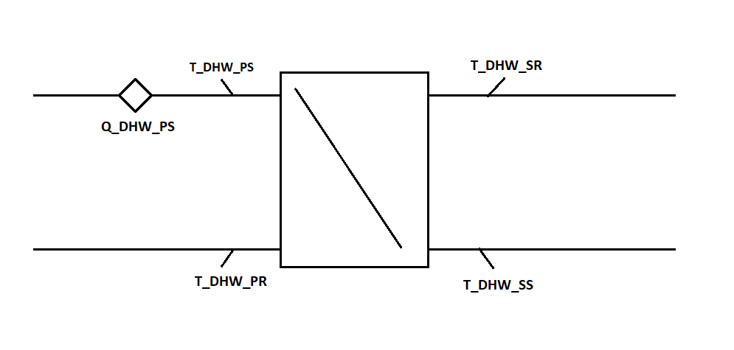

Figure 1 Heat Exchanger